From: https://onezero.medium.com/scientists-release-the-first-image-of-a-massive-black-hole-a61913e55451

Scientists Release the First Image of a Massive Black Hole

Here’s how they did it



Shannon StironeFollow
Apr 10, 2019
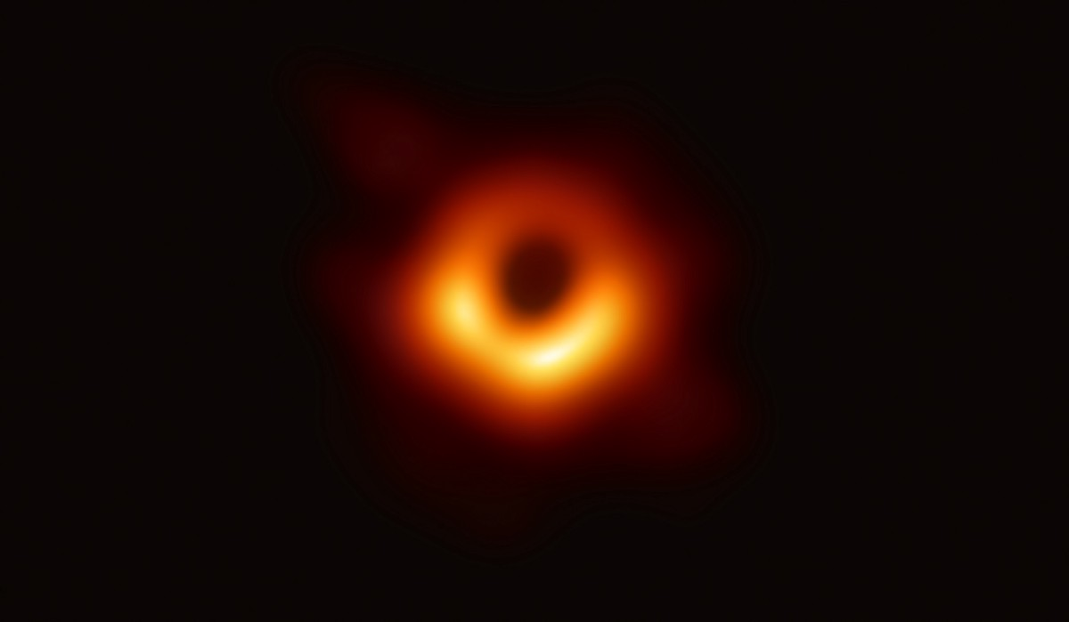
Credit: Handout/Getty Images

Of all the enigmatic phenomena in our universe, there’s perhaps one that has captured our attention and imagination the most, even though we had never actually seen one: the black hole. These space objects are so dense that even light cannot escape their grip. Ever since Einstein first proposed their existence, we’ve made
- simulations,
- art, and
- CGI
versions of what we imagine black holes could look like. But it wasn’t until this morning [April 10, 2019] that we saw a black hole for the first time. We have finally gazed into the cosmic abyss.
On Wednesday morning, teams of scientists around the world who work on an experiment called the Event Horizon Telescope released a much anticipated image of the ultramassive black hole at the center of the M87 galaxy. This galaxy is 55 million light-years away in the Virgo supercluster, and it is 6.5 billion times more massive than our sun. “You’re looking at a black hole that is essentially the size of our entire solar system,” says Sera Markoff, EHT team member and professor of theoretical astrophysics at the University of Amsterdam.
Capturing an image of a black hole is exceedingly difficult. It’s not like taking a photo of a planet, or a cluster of stars, or even another galaxy. It’s not as simple as using the Hubble Space Telescope. “We never thought this was possible,” says Priyamvada Natarajan, professor of astronomy and physics at Yale University.
Natarajan is not involved with the EHT team, but she’s been studying black holes for nearly 20 years. “We’re in the grip of a black hole!” she said, hardly able to contain her excitement. She and many others in her field have waited years for this data. It did not disappoint.
The Event Horizon Telescope is an array of radio telescopes around the world that are collectively so powerful that together they create a telescope as large as the Earth. The images and data they produce are so massive that the scientists had to wait to capture the images until hard drives existed that could hold all the information. “It is a huge technical feat,” says Natarajan.
“It’s a reframing of our cosmic view.”
The sheer quantity of information from the EHT left researchers with five petabytes of recorded data. “That’s more than a half a ton of hard drives,” says EHT team member Daniel Marrone. “It’s equivalent to 5,000 years of MP3 files or the entire selfie collection over a lifetime for 40,000 people.”
Despite the mind-boggling hard drives needed to complete the work, the actual image of M87 is only a few hundred kilobytes. “We had to collapse five petabytes of data into an image that’s five billion times smaller,” Marrone says.
The image itself contains enormous scientific value. “In astronomy and physics, pictures are extremely meaningful,” says Natarajan. “ [Seeing is believing!]
- They have agency to shift our thinking.
- They have a transformative capacity because you can see things visually because most of the things in astronomy we are dealing with the unseen.
- “It’s a reframing of our cosmic view.”
The photo shared by the EHT team shows the black hole in M87 as it was 55 million years ago, just 10 million years after the dinosaurs went extinct. The picture that we see is light that traversed the cosmos to reach our telescopes. It’s not new. It’s just new to us.
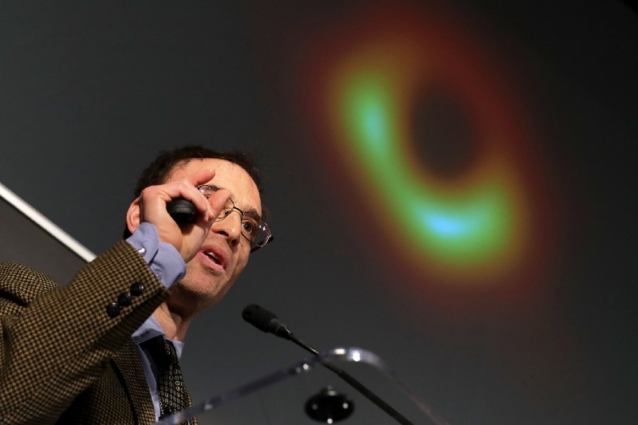
Event Horizon Telescope Director Sheperd Doeleman revealing the first image of a black hole at the National Science Foundation news conference on April 10, 2019. Credit: Chip Somodevilla/Getty Images
For the first time, we can see the [that is, derive 2D and 3D images of the M87] accretion disc and the shadow of the [its] event horizon—the point of light with no return—which is the dark circular shape in the center. Scientists are still unsure how the debris surrounding a black hole falls in or gets expelled out, so this photo will likely help answer some of those questions.
“Now we know that superheated, supermassive black holes existed at the center of most galaxies, but because they are so small, we’ve never seen one,” says Shep Doeleman, EHT director and Harvard senior research fellow.
We can only see black holes while
[A] they are eating material around them. If a star passes too close, for example, the mass of the black hole will rip that star to shreds, creating markers of gas and magnetic signals we can study from Earth.
OR
[B] Black holes also burp and emit high energy jets of gas that we can see. These jets are so intense they can carry the power of 10 billion supernova. While this ultramassive black hole is dead, maxed out on mass and no longer able to take in any more material, the sheer gravitational influence of it destroys anything that comes close, giving off beacons of light for us to see.
The findings from the EHT team are unprecedented and are sure to usher in a new era of our understanding of black holes as well as
- general relativity,
- dark matter, and
- a myriad cosmic mysteries.
“The EHT project is dedicated to the idea that we can make an image of this [(derived from the M87)] black hole,” said Doeleman. “We have seen what we thought was unseeable. Here it is.”

[Test question to the reader:
Just as with images of Earth from space, there are more meaningful and less meaningful views of this black hole to choose,
- The "few hundred kilobyte" iconic CGI picture at the start of this document is one of those most meaningful views that show the black event horizon of the hole.
- Many other candidate views would not show a black center.

True or False?]

an interactive visualization process involves a "data pipeline" in which the raw data is managed and filtered to a form that makes it suitable for rendering. This is often called the "visualization data". The visualization data is then mapped to a "visualization representation" that can be fed to a rendering system. This is usually called a "renderable representation". This representation is then rendered as a displayable image.^{[16]}
Nevertheless, she is a full, true, climate scientist, with publications in refereed journals!

